**The Wise Men**

**Reading: from Matthew 2:1-12**

After Jesus’ birth, wise men from the east came to Jerusalem. They asked, “Where is the child who has been born to be king of the Jews? We saw his star when it rose. Now we have come to worship him.”

When King Herod heard about it, he was very upset. He called together all the chief priests of the people. He asked where the Messiah was going to be born “In Bethlehem in Judea,” they replied.

Then Herod secretly called for the wise men. He found out from them exactly when the star had appeared. He sent them to Bethlehem.

After the wise men had listened to the king, they went on their way. The star they had seen when it rose went ahead of them. It finally stopped over the place where the child was. When they saw the star, they were filled with joy. They went to the house. There they saw the child with his mother Mary. They bowed down and worshipped him. Then they opened their treasures. They gave him gold, frankincense and myrrh.

**Thought about the reading**

The story of the wise men is part of the Christmas story.

They probably arrived sometime after Jesus was born, when his family were staying in Bethlehem.

The wise men came from a country far away from Bethlehem, in the east. They had seen a new star appear in the sky and they knew it meant that someone special had been born. They wanted to find the special baby so that they could worship him and give him presents. So, they set off on a very long journey. It must have taken them months to get to Bethlehem.

Jesus changed their lives. When they heard about his birth, they left their families and homes to search for him. Today we don’t have to travel far, but we can still worship him by giving him our lives.

**Prayer**

Dear Jesus, thank you for the wise men who travelled such a long way to see you. Thank you that I don’t have to travel far to worship you. I don’t have treasure to give you, but I want to give you my life and to follow you.

Amen

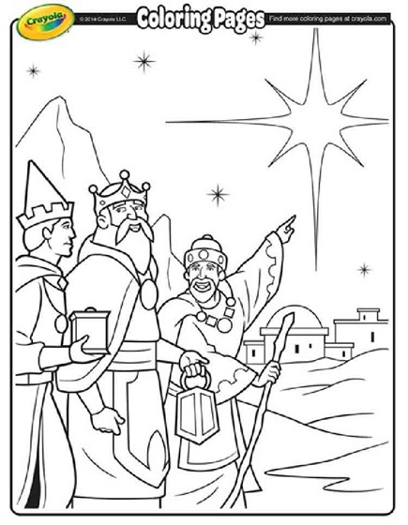

**Cambridge Causeway**

Spring 2025

Bible Study notes

**People changed by Jesus**

1. **The wise men**

By Chrissy Cole